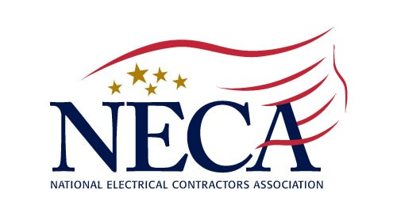
July 1, 2020
Media Contact:
Matt Kraus
Director, Communications
National Electrical Contractors Association
(301) 215-4554
matthew.kraus@necanet.org

On Wednesday, July 1, the NECA-supported United States-Mexico-Canada Trade Agreement (USMCA) entered into force, marking a new era in North American trade. This final agreement was signed by the three nations on December 10, 2019, and subsequently ratified in the following months. David Long, chief executive officer of NECA, issued the following statement to mark this moment:

“NECA has supported the USMCA from the beginning, and we are thrilled that it is now coming to fruition. This new agreement provides abundant opportunities for our member companies and electrical construction as a whole, incentivizing economic growth, offering strong worker protections, and ultimately creating more jobs for America’s workforce. Once more, I would like to thank President Trump, his administration, and Congressional Leadership for bringing this important agreement to the finish line.”

ABOUT THE NATIONAL ELECTRICAL CONTRACTORS ASSOCIATION
NECA is the voice of the $171 billion electrical construction industry that brings power, light and communication technology to buildings and communities across the United States. NECA’s national office in Bethesda, Md., and 118 local chapters advance the industry through advocacy, education, research and standards development. Go to www.necanet.org for more information.

###

