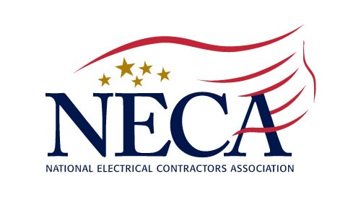
December 17, 2019
Media Contact:
Elise Baker
Director, Communications
National Electrical Contractors Association
(240) 800-5010
elise.baker@necanet.org

ELECTRICAL CONTRACTORS CONGRATULATE PRESIDENT TRUMP FOR SUCCESSFUL NEGOTIATIONS LEADING TO NEW UNITED STATES-MEXICO-CANADA TRADE AGREEMENT

The Chief Executive Officer of the National Electrical Contractors Association (NECA), David Long, issued the following statement in reaction to the signing of the United States-Mexico-Canada Agreement (USMCA):

“The historic signing of the United States-Mexico-Canada Agreement (USMCA) marks a significant turning point in the exercising of fair trade and labor practices across North America. I congratulate President Trump on this significant accomplishment. For too long, the troublesome NAFTA agreement has inhibited the economic growth of the middle class and the industry NECA represents. USMCA will help incentivize over $68 billion in new economic activity and it includes some of the most robust worker protections of any trade agreement ever negotiated.

The USMCA will allow our economy to continue on its upward trend and create more work for our contractors. This new agreement will not only allow our contractors to prosper with more opportunities, but it will also create more good-paying jobs for our electricians, who are the most talented workers in America. I thank President Trump and his administration for this agreement.”

ABOUT THE NATIONAL ELECTRICAL CONTRACTORS ASSOCIATION
NECA is the voice of the $171 billion electrical construction industry that brings power, light and communication technology to buildings and communities across the United States. NECA’s national office in Bethesda, Md., and 118 local chapters advance the industry through advocacy, education, research and standards development. Go to www.necanet.org for more information.

###

