July 16, 2020
Media Contact:
Matt Kraus
Director, Communications
National Electrical Contractors Association
301-215-4554
matthew.kraus@necanet.org

NECA Announces Details, Pricing Structure for NECA 2020 LIVE
Registration Opens Aug. 3 for Virtual Convention & Trade Show

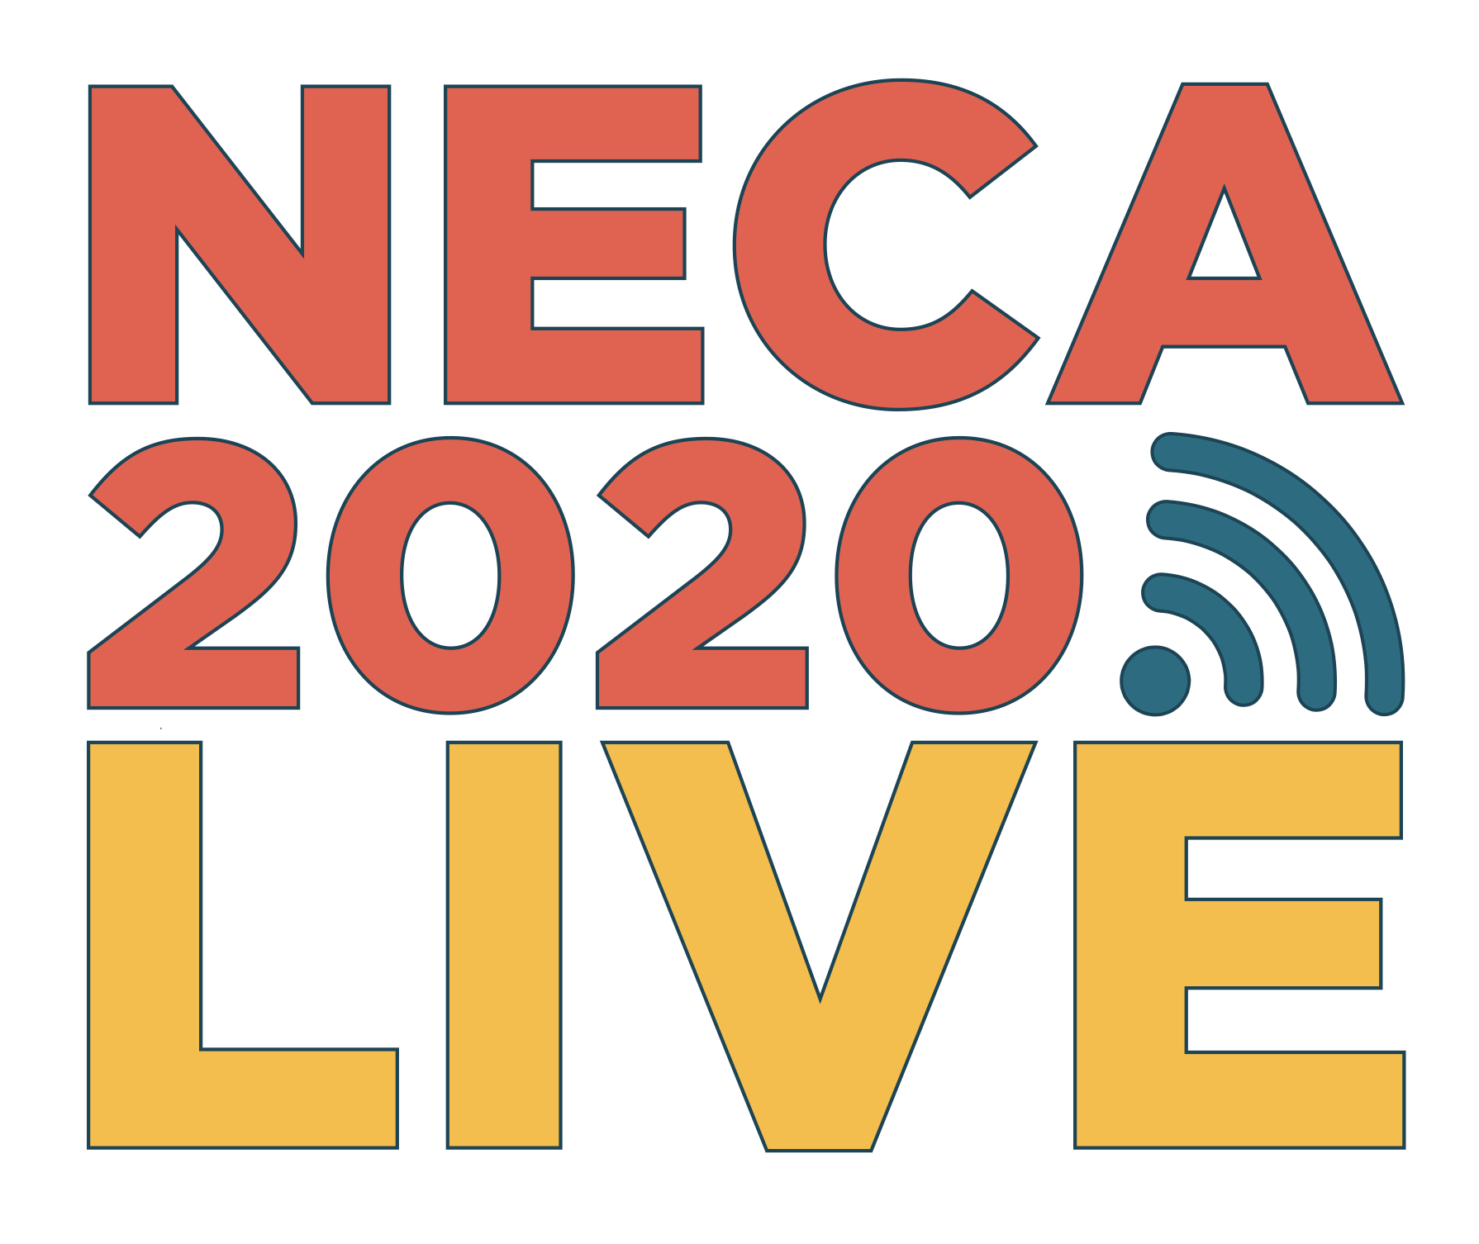

Bethesda, Md.— The National Electrical Contractors Association (NECA) today announced details including the pricing structure for NECA 2020 LIVE, the virtual Convention & Trade Show which will take place Oct. 6–8. NECA is harnessing cutting-edge technology to deliver all the benefits of the NECA Convention—including an interactive trade show floor, extensive educational opportunities, and inspiring talks—as well as all the freedom that comes from an online experience. An emphasis was also made on making this event accessible and valuable to NECA members amidst these uncertain times, enabling them to send more members than ever and continue to develop talent within their companies.

Full registration for NECA 2020 LIVE will be available Aug. 3 at the following prices.
- $200 per individual registrant for NECA members before Sept. 15
- $250 per individual registrant for NECA members after Sept. 15
- $500 per individual registrant for non-members
- Free registration is available for members of NECA Student Chapters

“We’re in unprecedented times in 2020, and at NECA National we have a fiduciary responsibility to our members in order to help get them through this challenging economy,” said NECA CEO David Long. “This pricing structure will allow our entire membership to register for NECA 2020 LIVE, and we feel this is an incredible value that enables companies to provide our cutting-edge education and industry-best exhibits to their entire staff in this difficult year.”

In planning the virtual convention, NECA is focusing on a “Five-Star Approach” to create a brand new experience. NECA 2020 LIVE is designed to Educate, Engage, Entertain, Excite, and Expand.

“This virtual convention is going to be a unique experience, unlike any NECA has done before, and we will surpass the level of quality our members have come to expect from our organization,” Long said. “I’m so excited about the experiences and education we are going to provide attendees, and the fact that this will lead to a whole new audience of contractors and other industry professionals being exposed to what NECA has to offer.”

AN ENTIRE CONVENTION AT YOUR FINGERTIPS
Thanks to innovative technology and the convenience afforded by a virtual convention, attendees will find NECA 2020 LIVE to be more connected than ever. Those attending education sessions will find the highest quality of instructors in NECA Convention history. With figures ranging from the powerful leadership speaker Alex Willis, to the communications maverick Sima Dahl and the thought-provoking Dr. Gustavo Grodnitzky, education at NECA 2020 LIVE will better than ever. David Meade will serve as emcee, guiding attendees through the Convention and presenting on topics such as leading and selling in a virtual environment, the psychology of persuasion, and body language.

Additionally, through the NECA 2020 LIVE virtual platform, attendees can experience every single minute of education offered, along with other talks and general sessions, with archived recordings available for viewing 30 days after the fact.

NECA provides the best trade show floor in the industry, and that is not changing with NECA 2020 LIVE. Attendees will find a robust virtual exhibit hall experience, where they can interact directly with exhibiting company executives as well as other attendees, download product information into a virtual swag bag, attend trade show education and new product demonstrations, enter for a chance to win big prizes in our daily “Play to Win” game, and much, much more.

Finally, the first 1,500 full NECA member registrants for NECA 2020 LIVE will receive a special “Swag Box,” featuring items such as a tote bag, lighted glasses, earbuds, and more!

NECA 2020 LIVE AT A GLANCE

Here is an overview of what attendees and NECA members can expect each day from NECA 2020 LIVE.

Monday, Oct. 5
- 10 a.m. – 12 p.m.: Green Energy Challenge
- 1 p.m. – 4 p.m.: NECA Board of Governors Meeting
Tuesday, Oct. 6
- 9 a.m.: Fireside Chat with NECA CEO David Long
- 10 a.m. – 3:55 p.m.: Trade Show
- 10:15 a.m. – 3:55 p.m.: 28 Education Sessions
- 12 p.m.: Bourbon and Chocolates sponsored by Graybar
- 4:30 p.m.: Opening Reception featuring the Milwaukee Tool Shed Band
Wednesday, Oct. 7
- 9:30 a.m.: General Session speaker Victoria Arlen, ESPN host and Paralympic athlete
- 10 a.m. – 3:55 p.m.: Trade Show
- 10:15 a.m. – 3:55 p.m.: 28 Education Sessions
- 12 p.m.: Chili Recipe presentation by Chef George Rodrigues (“Chopped,” “Beat Bobby Flay”)
- 4:30 pm.: Prize drawings
Thursday, Oct. 8
- 9:30 a.m.: General Session speaker Retired Lt. Gen. Nadja West
- 10 a.m. – 3:55 p.m.: Trade Show
- 10:15 a.m. – 3:55 p.m.: 28 Education Sessions
- 1 p.m.: NECA Awards, Grand Prize Drawings
- 4:30 p.m.: Closing Reception

Registration will open Aug. 3 on www.necaconvention.org. Follow NECA on social media to stay up-to-date on all the latest news.

ABOUT THE NATIONAL ELECTRICAL CONTRACTORS ASSOCIATION
NECA is the voice of the $171 billion electrical construction industry that brings power, light, and communication technology to buildings and communities across the United States. NECA's national office in Bethesda, Md., and 118 local chapters advance the industry through advocacy, education, research, and standards development. Go to www.necanet.org for more information.
###

